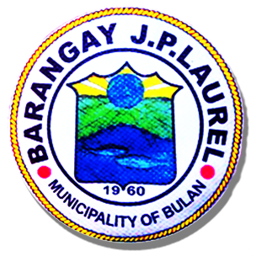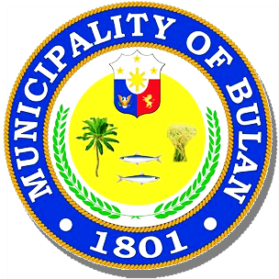Republic of the Philippines

**MUNICIPALITY OF BULAN**

Sorsogon  SORSOGON

**BARANGAY J.P. LAUREL**

OFFICE OF THE PUNONG BARANGAY

**BARANGAY CLEARANCE**

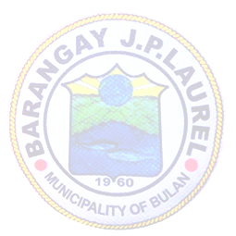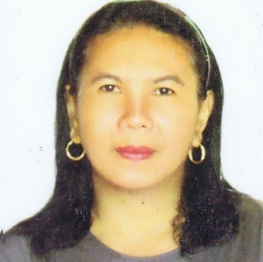

**BARANGAY OFFICIALS**

**NORIE G. CAÑEZAL**

**Punong Barangay**

**BARANGAY KAGAWAD**

**MARY JANE G. ESQUILLO**

**JUNIE G. BREZUELA**

**LERMA O. GRANADIL**

**RENAN G. GOLLOSO**

**VENER P. BERANIA**

**FLORENCE M. SUS**

**JOSEPH H. ALMOGUERA**

**SK CHAIRMAN**

**RONNEL G. GUETA**

**JONNA B. AGNE**

Barangay Secretary

**AGNES R. JUAB**

Barangay Treasurer

**To Whom It May Concern:**

This is to certify that ______________________________, ___ years old, Filipino citizen, single/married and postal address at Barangay J.P. Laurel, Bulan, Sorsogon, is of good moral character and law abiding citizen, found no complaint against her/him at this barangay.

This further certifies that the above-mentioned person is neither connected nor a member of any subversive organization.

This certification is issued upon request of the interested party this ___ day of _________________ 2022 at the office of the Punong Barangay, Barangay **J.P. Laurel, Bulan, Sorsogon, Philippines** for whatever purpose it may serve.

.

*Thumb marks*

Paid O.R. No**.:___________________**

Issued on: _­­­_____________________

Issued at: ­ JP. Laurel, Bulan, Sorsogon

Applicant Signature

Approved:

***NORIE G. CAÑEZAL***

Punong Barangay

Attested:

***JONNA B. AGNE***

Barangay Secretary

//.om~.22